Found Quasars around PLCK G218.9+55.5 (RA-156.28233 dec-18.908328)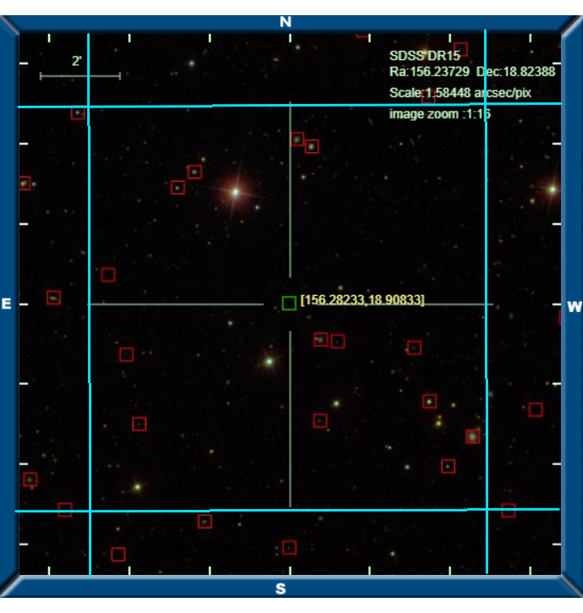

Image, blue radius around PLCK G218.9+55.5 is 5” from skysurver.sdss.org

|  |  |  |  |  |  |  |
| --- | --- | --- | --- | --- | --- | --- |
| **Quasar Name** | **Classification on SDSS** | **Redshift** | **RA** | **dec** | **Spectrum** | **Distance (arcmin)** |
| 1237667781212308058 | QSO | 1.991876 | 156.354638087263 | 18.8875596256729 | [spec](http://skyserver.sdss.org/dr15/en/get/SpecById.ashx?id=6625031548298043392) | <5 |

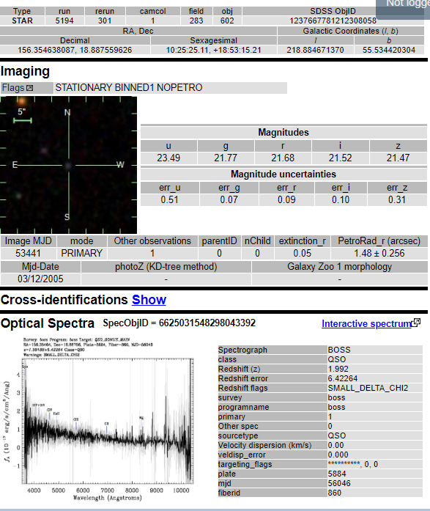

|  |
| --- |
| [Info Page 1](http://skyserver.sdss.org/dr15/en/tools/explore/Summary.aspx?id=1237667781212308058) |

|  |  |  |  |  |  |  |
| --- | --- | --- | --- | --- | --- | --- |
| **Star Name** | **Classification on SDSS** | **Redshift** | **RA** | **dec** | **Spectrum** | **Distance (arcmin)** |
|  |  |  |  |  | [spec](http://skyserver.sdss.org/dr15/en/get/SpecById.ashx?id=8392655381206114304) |  |
|  |  |  |  |  | [spec](http://skyserver.sdss.org/dr15/en/get/SpecById.ashx?id=3229192882808186880) |  |
|  |  |  |  |  | [spec](http://skyserver.sdss.org/dr15/en/get/SpecById.ashx?id=6625018903914323968) |  |
|  |  |  |  |  | [spec](http://skyserver.sdss.org/dr15/en/get/SpecById.ashx?id=2674072815140890624) |  |
|  |  |  |  |  | [spec](http://skyserver.sdss.org/dr15/en/get/SpecById.ashx?id=3212305758410532864) |  |
|  |  |  |  |  | [spec](http://skyserver.sdss.org/dr15/en/get/SpecById.ashx?id=8392644935845650432) |  |

|  |  |  |  |  |  |  |
| --- | --- | --- | --- | --- | --- | --- |
| **Qalaxy Name** | **Classification on SDSS** | **Redshift** | **RA** | **dec** | **Spectrum** | **Distance (arcmin)** |
|  |  |  |  |  | [spec](http://skyserver.sdss.org/dr15/en/get/SpecById.ashx?id=2674068142216472576) |  |
|  |  |  |  |  | [spec](http://skyserver.sdss.org/dr15/en/get/SpecById.ashx?id=2674070066361821184) |  |
|  |  |  |  |  | [spec](http://skyserver.sdss.org/dr15/en/get/SpecById.ashx?id=2917300186575300608) |  |
|  |  |  |  |  | [spec](http://skyserver.sdss.org/dr15/en/get/SpecById.ashx?id=6625020003425951744) |  |
|  |  |  |  |  | [spec](http://skyserver.sdss.org/dr15/en/get/SpecById.ashx?id=6624849304245739520) |  |
|  |  |  |  |  | [spec](http://skyserver.sdss.org/dr15/en/get/SpecById.ashx?id=2674068417094379520) |  |
|  |  |  |  |  | [spec](http://skyserver.sdss.org/dr15/en/get/SpecById.ashx?id=2674068691972286464) |  |